**DIT092**

**Team name: Random Fantasy**

* Team members:

1. George Sarkisian: gussarksa@student.gu.se 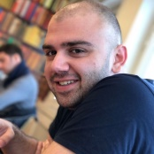
2. Albin Gustafson: gusgusal@student.gu.se 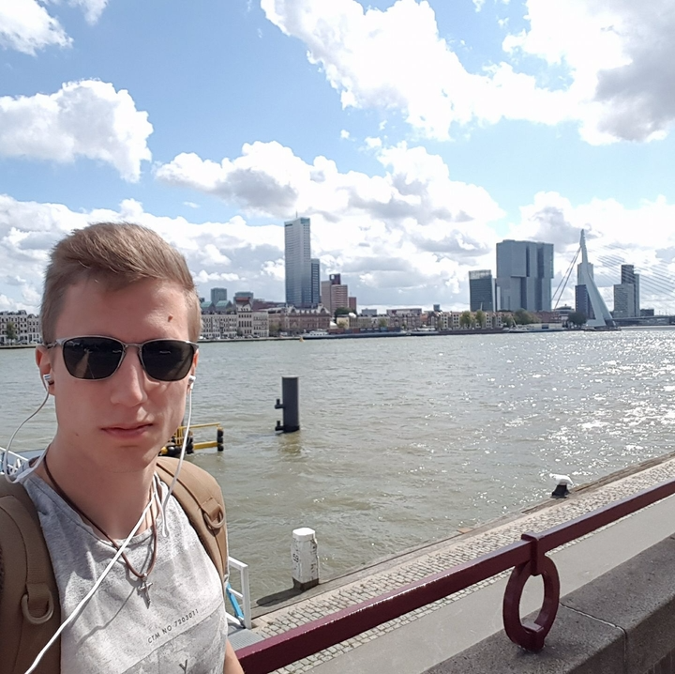
3. Kaijie Xiong: gusxioka@student.gu.se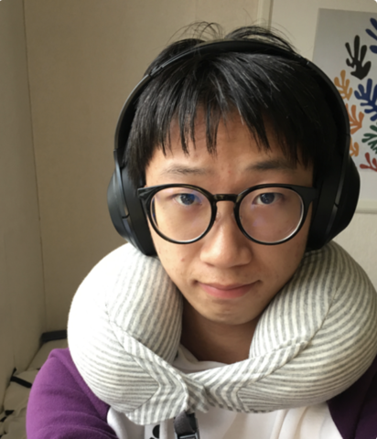
4. Fredrik Salmi: gussalmfr@student.gu.se 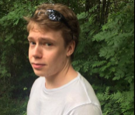
5. Haoyang lyu: guslyuha@student.gu.se 
6. Patrik Gardsten: gusgardpa@student.gu.se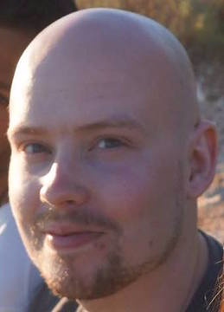

* Sit down and discuss how many hours a week you will work and on what days?

We are going to meet every Fridays and Mondays after lectures where we will divide the tasks.

At the meeting we will discuss what we have done and if we feel like we aren’t progressing

as planned we will discuss the problems and change the plan to better suit us for a better

teamwork cooperation.

* How does each of you look at this project? Are you in it to get a Pass, a high pass? To learn something specific?

All the members in the group are willing to get a high pass and we are willing to learn new skills

like: GUI and working in group environment.

* How will you divide the workload between the team members? Are there certain skillsets that some team member possesses that should be used?

We are going to divide the task between team members as equally as we can and we are going to help each other to achieve our goals. Haoyang lyu is going help us with GUI.

* Will you work according to a specific methodology?

We are going with the agile method. Since this is the first real teamwork programming we dont really

know how we are going to work to for the best result so we might change the plan as we go on. We will meet two times a week on Monday and Friday to discuss what we have done and what we should do, but as said above the plan might change as we run in to problems and we adapt in order to improve the effectiveness.

* We created Slack group, Trello and Gitlab. We posted the tasks in the Trello and devided the

workload.

Best regards

Team Random Fantasy